**Hello  
I’m Rajat Thawal**

[**rajat-1.blogspot.com**](http://rajat-1.blogspot.com/)

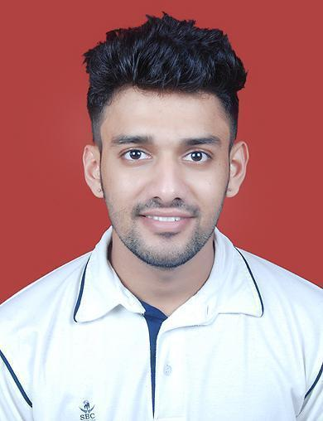

14/3, A-5, Millennium Towers

Sector - 9, Sanpada

Navi Mumbai, 400705

**+91 9004031308**

**rajat.1@outlook.com**

**Skills**

I have worked on projects using technologies HTML, CSS, JavaScript, jQuery, Angular Framework, Ionic Framework, Java, JDBC, mySQL Server, Spring Boot Framework, Maven Build Tool, Bootstrap, Python.

I have end-to-end web & mobile application development (front-end, back-end, database) experience.

Apart from Technical Expertise I have excellent soft skills, team building, leadership, analytical thinking, interpersonal, oral and written communication skills.

**Experience**

May 2022 - July 2022

**Capgemini Technology Services, Mumbai** *- Consultant*

* De VolksBank (Netherlands) Project - Banking
  + De Volks Bank has tie-up or sub banks – SNS Bank, ASN Bank, Regio Bank, BLG Wonen for which I was responsible for styling and CSS part in which I worked in cross-functional teams.
  + Technologies Used: AWS, Restful APIs, ReactJS

January 2022 – April 2022

**Cognizant Technology Services, Mumbai** *– Software Engineer*

(Payroll from Unique Hire Consulting)

* Mobile Manulife Touch - Connecting with fellow team mates on technical aspects of the mentioned project
* Figma UI / UX Design Framework | Java | Oracle | System Design | Conversion of Web UI and Web App (Angular Framework Project) to Mobile App (Ionic Framework). Technologies I used were Photoshop, Miro Board and other best practices

August 2020 - December 2021

**Reliance Securities, Thane** *- Developer*

* SuperApp - Health | Wealth | Lifestyle | Education - Diversified
* Zeplin Designs - Brainstorming on User Experience and removing bottlenecks and backlogs after each sprint session using tools like jQuery, ExpressJS, MongoDB, nodeJS

July 2019 - March 2020

**Sabado Technologies, Bengaluru** *- Trainee*

* Vitality - In this project Ionic framework (Similar to Angular) was used for front-end design and development and using CORS the connectivity was established with Java, Spring Boot, JDBC, mySQL server, Oracle using Tomcat Server
* Minerva - GE Healthcare Project using MVC framework, database design, coding design patterns, OOPS concepts, CRUD operations, SDLC

July 2018 - Feb 2019

**Sahu Technologies, Mumbai** *- Web Developer*

I was involved in the development of these websites

[freeshopping.in](http://www.freeshopping.in/) ideapreneurindia.com classlink.com

June 2015 - June 2015

**Kalpana Marine, Mumbai** *- Engineer*

* Various Turbocharger Overhauling Works, Glass Bead Blasting & Horizontal Shaper M/C

**Education**

July 2013 - May 2018

**K. J. Somaiya College of Engineering, Mumbai** *- Bachelor of Engineering*

I have completed Mechanical Engineering and did Core Java courses from NIIT institute, I have worked on a project to design and develop Solar Cooling System

**Roles & Responsibilities**

* Cognizant Technology Services
  + Manulife Mobile Touch
    - Angular to Ionic Framework based project conversion along with design guidelines from client company Manulife which uses its own CDS (Connected Design System)
* Reliance Securities - SuperApp
  + As the name suggests, the project includes all aspects such as equity, stocks, F&O, Digital Gold, etc.
  + Working with Angular Directives and DOM manipulation
* Sabado Technologies
  + Vitality – Java Spring Boot
  + Minerva - AngularJS
* Sahu Technologies
  + FreeShopping.in - Coupon Portal
    - Reviewing the API endpoints and checking whether they are working fine in terms of request and response using Postman
  + IdeaPreneurIndia.com - Media Portal - Development using basic and HTML tags
  + ClassLink.com – Advanced HTML, CSS Media Query, Ruby Programming
* Kalpana Marine
  + Supervising Daily Tasks at Japanese Tie-Up Workshop and coordinating with suppliers for on-time delivery